**Task – CRUD operation on MYSQL**

**Code:**

**User_index.ejs**

<!DOCTYPE html>

<html lang="en">

<head>

<style>

.feed {

min-height: 80vh;

}

</style>

<title>CRUD Operations</title>

<meta charset="utf-8">

<meta name="viewport" content="width=device-width, initial-scale=1">

<link rel="stylesheet" href="https://maxcdn.bootstrapcdn.com/bootstrap/4.3.1/css/bootstrap.min.css">

<script src="https://ajax.googleapis.com/ajax/libs/jquery/3.4.1/jquery.min.js"></script>

<script src="https://cdnjs.cloudflare.com/ajax/libs/popper.js/1.14.7/umd/popper.min.js"></script>

<script src="https://maxcdn.bootstrapcdn.com/bootstrap/4.3.1/js/bootstrap.min.js"></script>

</head>

<body>

<section id="title-bar">

<div class="navbar navbar-expand-lg navbar-dark bg-dark">

<div class="container-fluid px-5 py-1">

<a class="navbar-brand " href="#">CRUD Operation</a>

<button class="navbar-toggler" type="button" data-bs-toggle="collapse" data-bs-target="#navbarScroll" aria-expanded="false">

<span class="navbar-toggler-icon"></span>

</button>

<div class="collapse navbar-collapse" id="navbarScroll">

<ul class="navbar-nav mx-3 me-auto">

<li class="nav-item">

<a href="#" class="nav-link active">Home</a>

</li>

<li class="nav-item">

<a href="#" class="nav-link">University</a>

</li>

</ul>

</div>

</div>

</div>

</section>

<div class="container mt-2 feed">

<a href="/add" class="btn btn-sm btn-primary">Add User</a><br/><br/>

<table class="table table-dark table-striped">

<thead>

<tr>

<th>Course id</th>

<th>Course name</th>

<th>department name</th>

<th>institute name</th>

<th>university name</th>

</tr>

</thead>

<tbody>

<% users.forEach(function(university){ %>

<tr>

<td><%= university.cid %></td>

<td><%= university.cname %></td>

<td><%= university.dname %></td>

<td><%= university.iname %></td>

<td><%= university.uname %></td>

<td>

<a href="edit/<%= university.id %>" class="btn btn-sm btn-primary">Edit</a>

<a href="delete/<%= university.id %>" class="btn btn-sm btn-danger">Delete</a>

</td>

</tr>

<% }); %>

</tbody>

</table>

</div>

<!-- footer Section -->

<footer class="bg-dark navbar-static-bottom ">

<div class="contanier-fluid text-center p-4 pb-1">

<p class="text-white">© Copyright 2021</p>

</div>

</footer>

</body>

</html>

**User_edit.ejs**

<!DOCTYPE html>

<html lang="en">

<head>

<style>

.feed {

min-height: 80vh;

}

</style>

<title>CRUD Operations</title>

<meta charset="utf-8">

<meta name="viewport" content="width=device-width, initial-scale=1">

<link rel="stylesheet" href="https://maxcdn.bootstrapcdn.com/bootstrap/4.3.1/css/bootstrap.min.css">

<script src="https://ajax.googleapis.com/ajax/libs/jquery/3.4.1/jquery.min.js"></script>

<script src="https://cdnjs.cloudflare.com/ajax/libs/popper.js/1.14.7/umd/popper.min.js"></script>

<script src="https://maxcdn.bootstrapcdn.com/bootstrap/4.3.1/js/bootstrap.min.js"></script>

</head>

<body>

<section id="title-bar">

<div class="navbar navbar-expand-lg navbar-dark bg-dark">

<div class="container-fluid px-5 py-1">

<a class="navbar-brand " href="#">CRUD Operation</a>

<button class="navbar-toggler" type="button" data-bs-toggle="collapse" data-bs-target="#navbarScroll" aria-expanded="false">

<span class="navbar-toggler-icon"></span>

</button>

<div class="collapse navbar-collapse" id="navbarScroll">

<ul class="navbar-nav mx-3 me-auto">

<li class="nav-item">

<a href="#" class="nav-link active">Home</a>

</li>

<li class="nav-item">

<a href="#" class="nav-link">University</a>

</li>

</ul>

</div>

</div>

</div>

</section>

<div class="container mt-2 feed">

<form action="/update" method="post">

<input type="hidden" value="<%= user.id %>" name="id">

<div class="form-group">

<label for="cid">Course ID</label>

<input type="text" class="form-control" id="cid" placeholder="Enter Course ID" value="<%= user.cid %>" name="cid" required>

</div>

<div class="form-group">

<label for="cname">Course name:</label>

<input type="text" class="form-control" id="cname" placeholder="Enter Course id" value="<%= user.cname %>" name="cname" required>

</div>

<div class="form-group">

<label for="dname">department name:</label>

<input type="text" class="form-control" id="dname" placeholder="Enter Course name" value="<%= user.dname %>" name="dname" required>

</div>

<div class="form-group">

<label for="iname">Institute name:</label>

<input type="text" class="form-control" id="iname" placeholder="Enter department name" value="<%= user.iname %>" name="iname" required>

</div>

<div class="form-group">

<label for="uname">University name:</label>

<input type="text" class="form-control" id="uname" placeholder="Enter University name" value="<%= user.uname %>" name="uname" required>

</div>

<button type="submit" class="btn btn-primary">Submit</button>

</form>

</div>

<!-- footer Section -->

<footer class="bg-dark navbar-static-bottom ">

<div class="contanier-fluid text-center p-4 pb-1">

<p class="text-white">© Copyright 2021</p>

</div>

</footer>

</body>

</html>

**User_add.ejs**

<!DOCTYPE html>

<html lang="en">

<head>

<style>

.feed {

min-height: 80vh;

}

</style>

<title>CRUD Operations</title>

<meta charset="utf-8">

<meta name="viewport" content="width=device-width, initial-scale=1">

<link rel="stylesheet" href="https://maxcdn.bootstrapcdn.com/bootstrap/4.3.1/css/bootstrap.min.css">

<script src="https://ajax.googleapis.com/ajax/libs/jquery/3.4.1/jquery.min.js"></script>

<script src="https://cdnjs.cloudflare.com/ajax/libs/popper.js/1.14.7/umd/popper.min.js"></script>

<script src="https://maxcdn.bootstrapcdn.com/bootstrap/4.3.1/js/bootstrap.min.js"></script>

</head>

<body>

<section id="title-bar">

<div class="navbar navbar-expand-lg navbar-dark bg-dark">

<div class="container-fluid px-5 py-1">

<a class="navbar-brand " href="#">CRUD Operation</a>

<button class="navbar-toggler" type="button" data-bs-toggle="collapse" data-bs-target="#navbarScroll" aria-expanded="false">

<span class="navbar-toggler-icon"></span>

</button>

<div class="collapse navbar-collapse" id="navbarScroll">

<ul class="navbar-nav mx-3 me-auto">

<li class="nav-item">

<a href="#" class="nav-link active">Home</a>

</li>

<li class="nav-item">

<a href="#" class="nav-link">University</a>

</li>

</ul>

</div>

</div>

</div>

</section>

<div class="container mt-2 feed">

<form action="/save" method="post">

<div class="form-group">

<label for="cid">Course id:</label>

<input type="text" class="form-control" id="cid" placeholder="Enter Course id" name="cid" required>

</div>

<div class="form-group">

<label for="cname">Course name:</label>

<input type="text" class="form-control" id="cname" placeholder="Enter Course name" name="cname" required>

</div>

<div class="form-group">

<label for="dname">department name:</label>

<input type="text" class="form-control" id="dname" placeholder="Enter department name" name="dname" required>

</div>

<div class="form-group">

<label for="iname">Institute name:</label>

<input type="text" class="form-control" id="iname" placeholder="Enter Institute name" name="iname" required>

</div>

<div class="form-group">

<label for="uname">University name:</label>

<input type="text" class="form-control" id="uname" placeholder="Enter University name" name="uname" required>

</div>

<button type="submit" class="btn btn-primary">Submit</button>

</form>

</div>

<!-- footer Section -->

<footer class="bg-dark navbar-static-bottom ">

<div class="contanier-fluid text-center p-4 pb-1">

<p class="text-white">© Copyright 2021</p>

</div>

</footer>

</body>

</html>

**App.js**

const path = require('path');

const express = require('express');

const ejs = require('ejs');

const bodyParser = require('body-parser');

const mysql = require('mysql');

const app = express();

const connection=mysql.createConnection({

host:'localhost',

user:'root',

password:'',

database:'coursedetails'

});

connection.connect(function(error){

if(!!error) console.log(error);

else console.log('Database Connected!');

});

//set views file

app.set('views',path.join(__dirname,'views'));

//set view engine

app.set('view engine', 'ejs');

app.use(bodyParser.json());

app.use(bodyParser.urlencoded({ extended: false }));

app.get('/',(req, res) => {

// res.send('CRUD Operation using NodeJS / ExpressJS / MySQL');

let sql = "SELECT * FROM university";

let query = connection.query(sql, (err, rows) => {

if(err) throw err;

res.render('user_index', {

users : rows

});

});

});

app.get('/add',(req, res) => {

res.render('user_add', {

});

});

app.post('/save',(req, res) => {

let data = {cid: req.body.cid, cname: req.body.cname, dname: req.body.dname, iname: req.body.iname, uname: req.body.uname};

let sql = "INSERT INTO university SET ?";

let query = connection.query(sql, data,(err, results) => {

if(err) throw err;

res.redirect('/');

});

});

app.get('/edit/:userId',(req, res) => {

const userId = req.params.userId;

let sql = `Select * from university where id = ${userId}`;

let query = connection.query(sql,(err, result) => {

if(err) throw err;

res.render('user_edit', {

user : result[0]

});

});

});

app.post('/update',(req, res) => {

const userId = req.body.id;

let sql = "update university SET cid='"+req.body.cid+"', cname='"+req.body.cname+"', dname='"+req.body.dname+"', iname='"+req.body.iname+"', uname='"+req.body.uname+"' where id ="+userId;

let query = connection.query(sql,(err, results) => {

if(err) throw err;

res.redirect('/');

});

});

app.get('/delete/:userId',(req, res) => {

const userId = req.params.userId;

let sql = `DELETE from university where id = ${userId}`;

let query = connection.query(sql,(err, result) => {

if(err) throw err;

res.redirect('/');

});

});

// Server Listening

app.listen(3000, () => {

console.log('Server is running at port 3000');

});

**Folder structure**

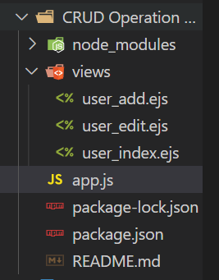

**Output:**

Home page

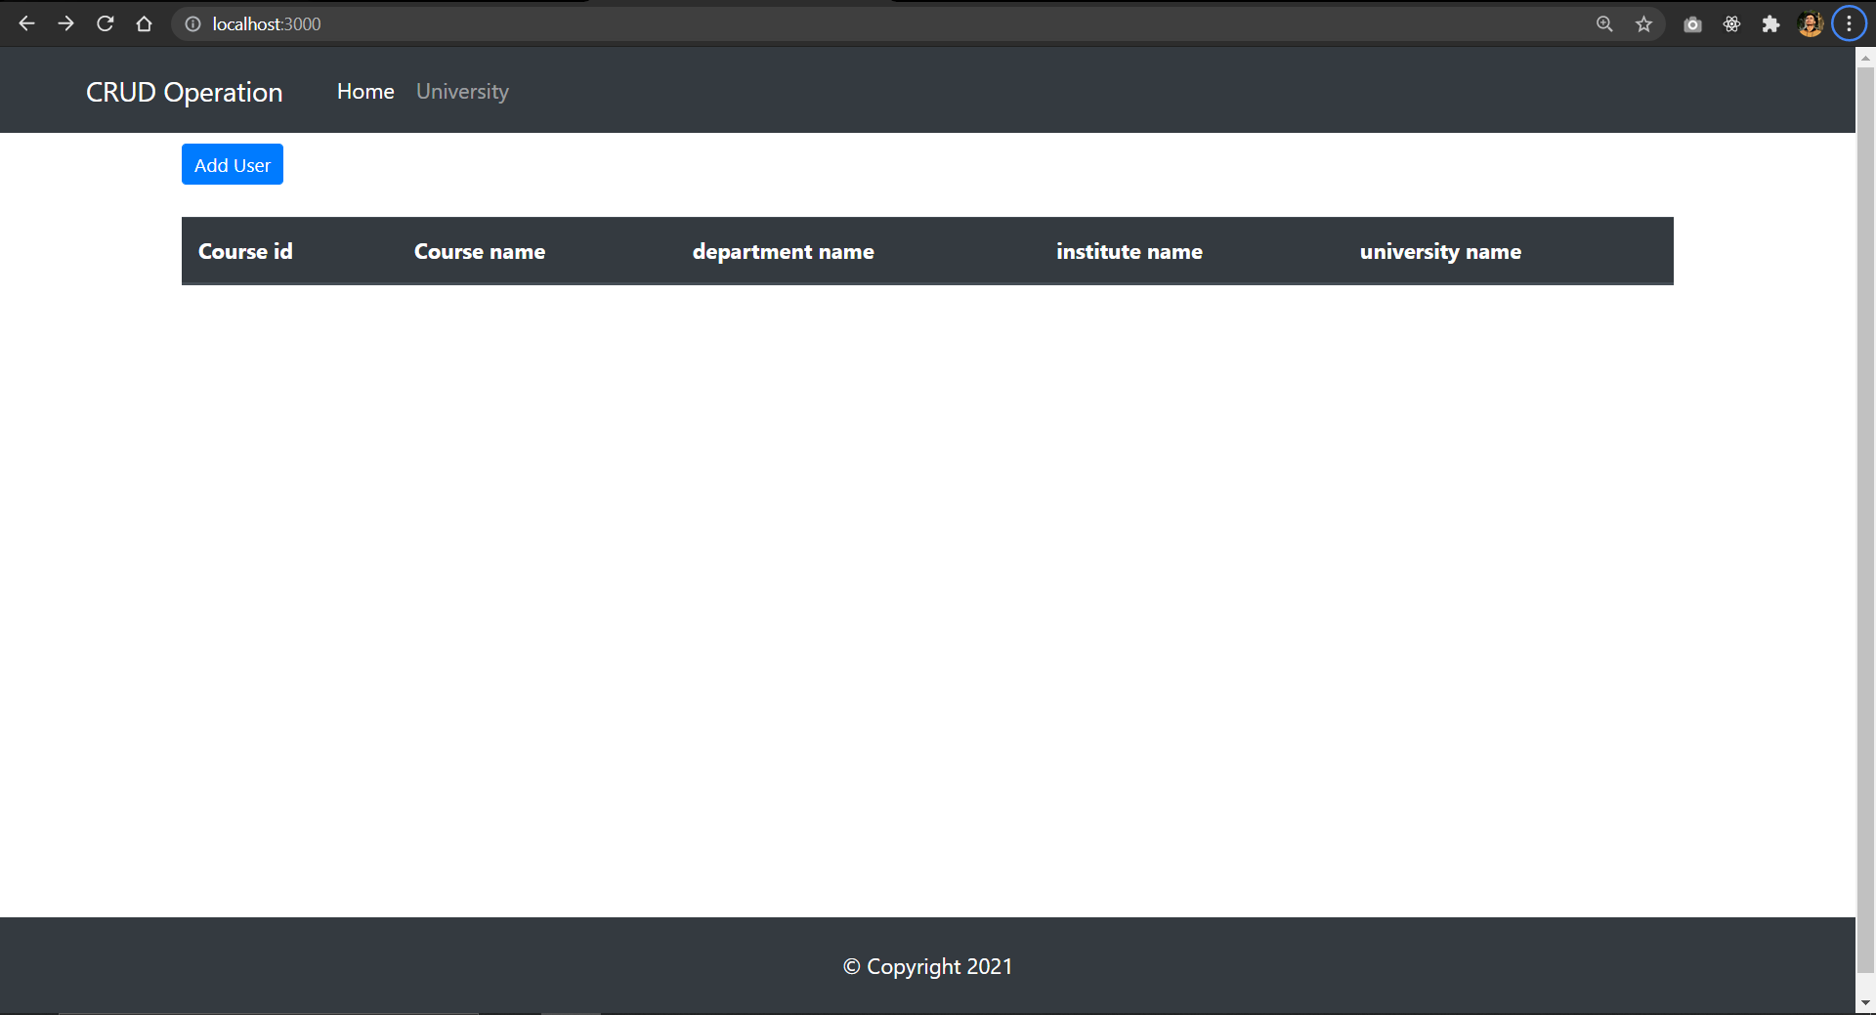

/add route

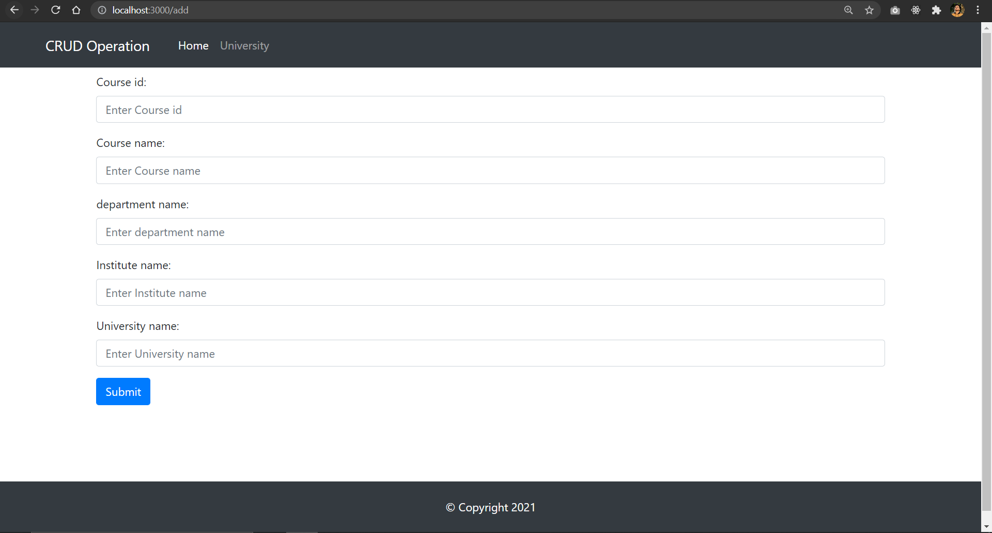

Display the data

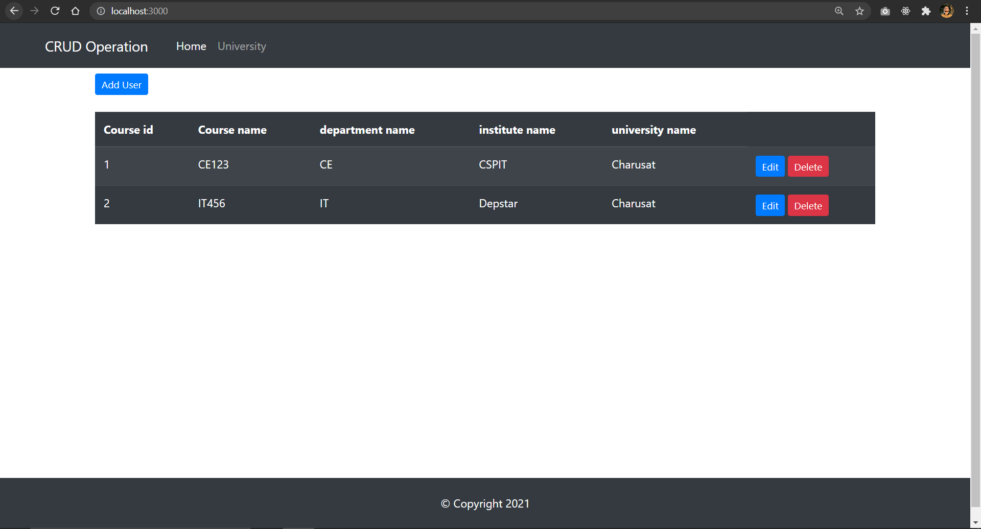

/edit route

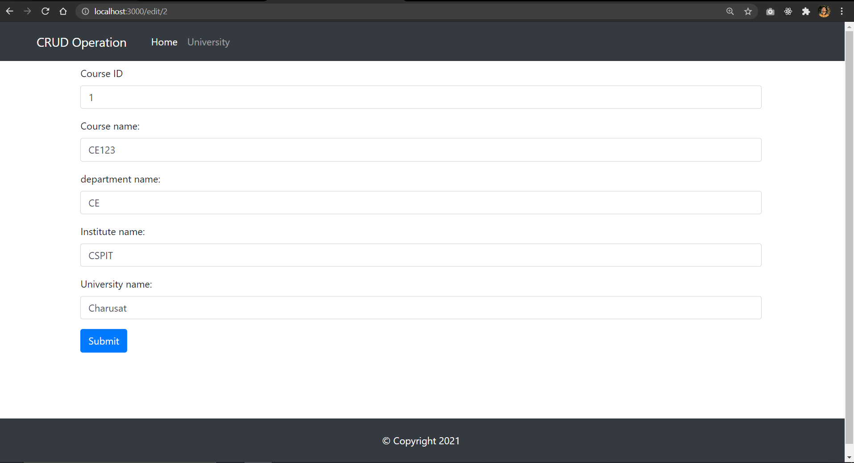

Delete button

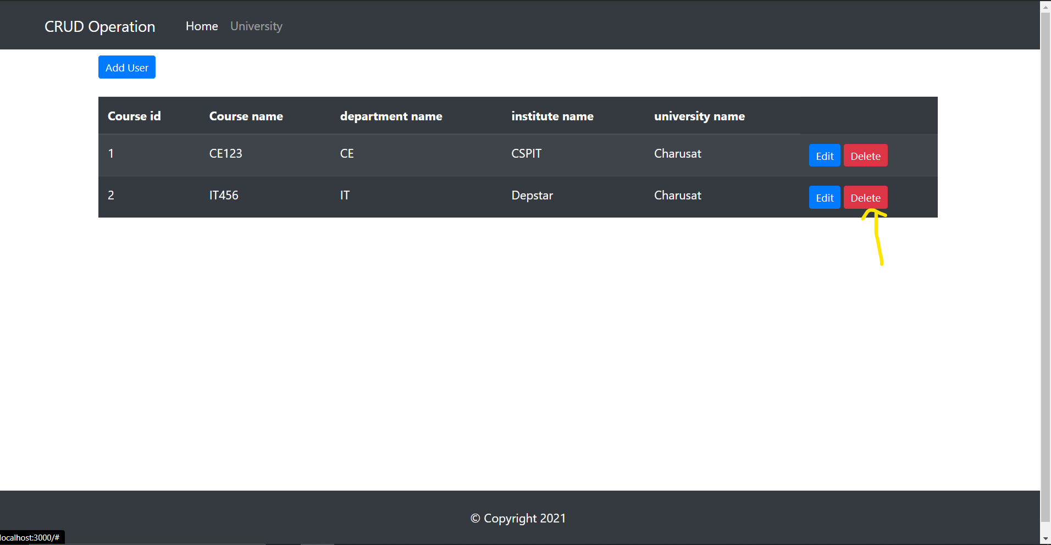

After delete id 2

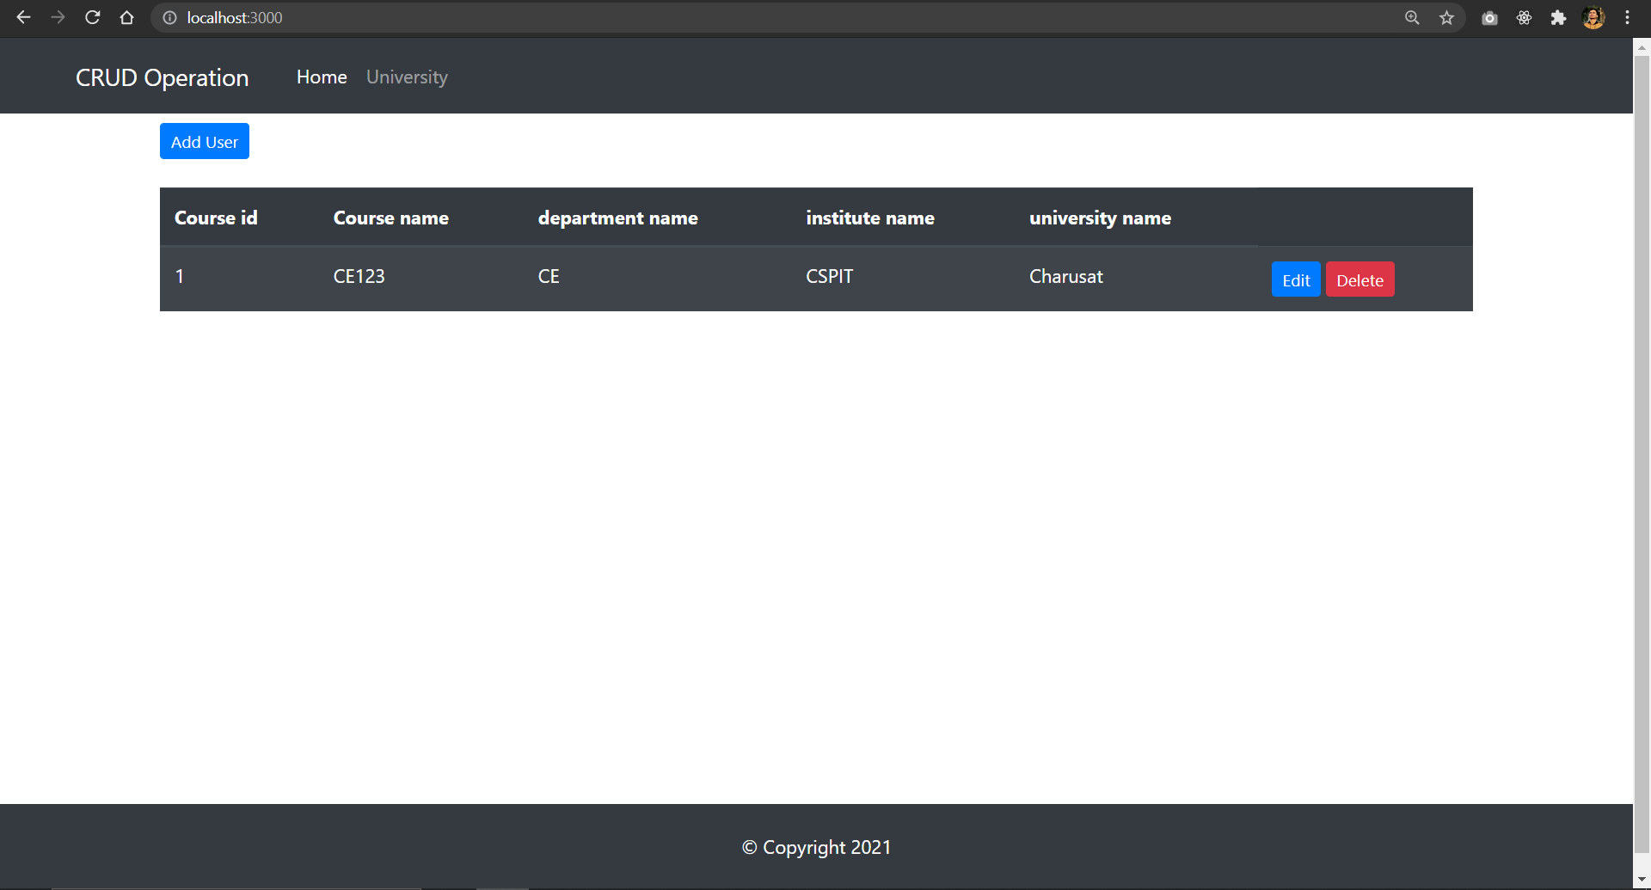

Table

